LAB 07
Task 01
The great circle distance is the distance between two points on the surface of a sphere. Let (x1, y1) and (x2, y2) be the geographi-cal latitude and longitude of two points.
Solution
import java.util.Scanner;
public class Circle {
public static void main(String[] args) {
Scanner input = new Scanner(System.in);
final double RADIUS = 6371.01;
System.out.print("Enter latitude of point 1 (in degrees): ");
double x1 = input.nextDouble();
System.out.print("Enter longitude of point 1 (in degrees): ");
double y1 = input.nextDouble();
System.out.print("Enter latitude of point 2 (in degrees): ");
double x2 = input.nextDouble();
System.out.print("Enter longitude of point 2 (in degrees): ");
double y2 = input.nextDouble();
x1 = Math.toRadians(x1);
y1 = Math.toRadians(y1);
x2 = Math.toRadians(x2);
y2 = Math.toRadians(y2);
double distance = RADIUS * Math.acos(
Math.sin(x1) * Math.sin(x2) + Math.cos(x1) * Math.cos(x2) * Math.cos(y1 - y2));
System.out.printf("The distance between the two points is %.2f km.%n", distance);
input.close();
}
}
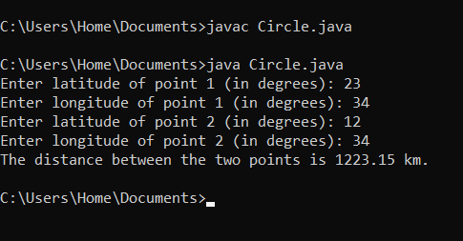

Lab task 02
Part (1)
Write a program that receives an ASCII code (an integer between 0 and 127) and displays its character.
Solution
import java.util.Scanner;
public class Ascii {
public static void main(String[] args) {
Scanner input = new Scanner(System.in);
System.out.print("Enter an ASCII code (0 to 127): ");
int code = input.nextInt();
char ch = (char) code;
System.out.println("The character for ASCII code " + code + " is " + ch);

input.close();
}
}
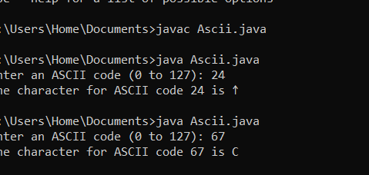
Part (2)
Write a program that receives a character and displays its Unicode.
Solution
import java.util.Scanner;
public class Unicode {
public static void main(String[] args) {
Scanner input = new Scanner(System.in);
System.out.print("Enter a character: ");
char ch = input.next().charAt(0);
int unicode = (int) ch;
System.out.println("The Unicode for character '" + ch + "' is " + unicode);

input.close();
}
}
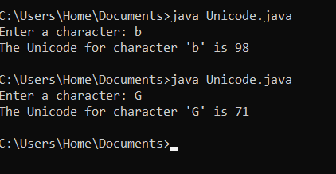

Lab task 03
- Write a program that prompts the user to enter an integer between 0 and 15 and displays its corresponding hex number.
Solution
import java.util.Scanner;
public class DecimalToHex {
public static void main(String[] args) {
Scanner input = new Scanner(System.in);

System.out.print("Enter a decimal value (0 to 15): ");
int decimal = input.nextInt();

if (decimal >= 0 && decimal <= 15) {
String hex = Integer.toHexString(decimal).toUpperCase();
System.out.println("The hex value is " + hex);
} else {
System.out.println(decimal + " is an invalid input");
}

input.close();
}
}
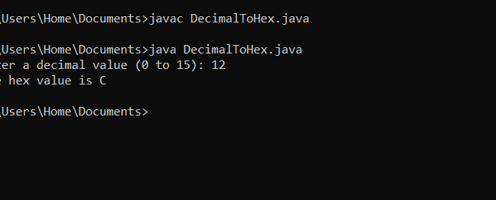
- Write a program that prompts the user to enter a hex digit and displays its corresponding binary number. Here is a sample run.
Solution
import java.util.Scanner;
public class HexToBinary {
public static void main(String[] args) {
Scanner input = new Scanner(System.in);
System.out.print("Enter a hex digit: ");
String hex = input.nextLine().toUpperCase();
if (hex.length() == 1 && "0123456789ABCDEF".contains(hex)) {
int decimal = Integer.parseInt(hex, 16);
String binary = Integer.toBinaryString(decimal);
System.out.println("The binary value is " + binary);
} else {
System.out.println(hex + " is an invalid input");
}

input.close();
}
}
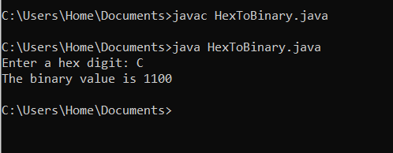

Lab task 04
Write a program that displays a random uppercase letter using the Math.random() method.
Solution
public class RandomUppercaseLetter {
public static void main(String[] args) {
int randomNum = (int)(Math.random() * 26);
char randomLetter = (char)('A' + randomNum);
System.out.println("The random uppercase letter is: " + randomLetter);
}
}
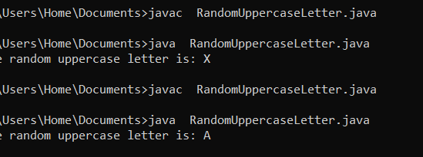

lab task 05
Write a program that checks whether a string is a palindrome. A string is a palindrome if it reads the same forward and backward. The words “mom,” “dad,” and “noon,” for instance, are all palindromes.
Solution
import java.util.Scanner;
public class PalindromeCheck {
public static void main(String[] args) {
Scanner input = new Scanner(System.in);
System.out.print("Enter a string: ");
String str = input.nextLine();
str = str.toLowerCase();
String reverse = "";
for (int i = str.length() - 1; i >= 0; i--) {
reverse += str.charAt(i);
}
if (str.equals(reverse)) {
System.out.println(str + " is a palindrome");
} else {
System.out.println(str + " is not a palindrome");
}

input.close();
}
}
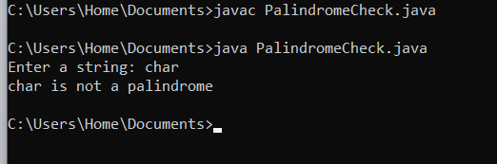

Lab task 06
Given a string consisting of exactly two words separated by a space. Print a new string with the first and second word positions swapped (the second word is printed first). This task should not use loops and if.
Solution
import java.util.Scanner;
public class SwapWords {
public static void main(String[] args) {
Scanner input = new Scanner(System.in);
System.out.print("Enter a string with two words: ");
String text = input.nextLine();
int spaceIndex = text.indexOf(' ');
String firstWord = text.substring(0, spaceIndex);
String secondWord = text.substring(spaceIndex + 1); System.out.println(secondWord + " " + firstWord);

input.close();
}
}
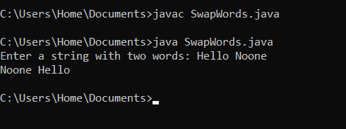

Lab task 07
Given a string that may or may not contain a letter of interest. Print the index location of the first and last appearance of f. If the letter f occurs only once, then output its index. If the letter f does not occur, then do not print anything.
Solution
import java.util.Scanner;
public class FindFIndex {
public static void main(String[] args) {
Scanner input = new Scanner(System.in);
System.out.print("Enter a string: ");
String str = input.nextLine();
int first = str.indexOf('f');
int last = str.lastIndexOf('f');
if (first == -1) {
}
else if (first == last) {
System.out.println(first);
}
else {
System.out.println(first + " " + last);
}

input.close();
}
}
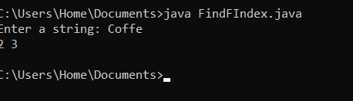
Lab Task 8
Given a string in which the letter h occurs at least twice. Remove from that string the first and the last occurrence of the letter h, as well as all the characters between them.
Solution
import java.util.Scanner;
public class RemoveHSection {
public static void main(String[] args) {
Scanner input = new Scanner(System.in);
System.out.print("Input: ");
String str = input.nextLine;
int first = str.indexOf('h');
int last = str.lastIndexOf('h');
String result = str.substring(0, first) + str.substring(last + 1);
System.out.println("Correct Answer: " + result);

input.close();
}
}
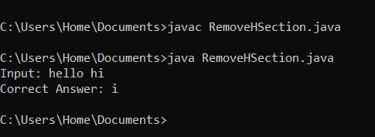
Lab Task 9
Given a string. Replace every occurrence of the letter h by the letter H, except for the first and the last ones.
Solution
import java.util.Scanner;
public class ReplaceH {
public static void main(String[] args) {
Scanner input = new Scanner(System.in);
System.out.print("Enter a string: ");
String str = input.nextLine();
int first = str.indexOf('h');
int last = str.lastIndexOf('h');
if (first == -1 || first == last) {
System.out.println(str);
} else {
String before = str.substring(0, first + 1);
String middle = str.substring(first + 1, last).replace('h', 'H');
String after = str.substring(last);
String result = before + middle + after;
System.out.println(result);
}

input.close();
}
}
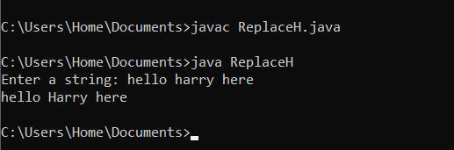
Lab Task 10
You are given a string. In the first line, print the third character of this string. In the second line, print the second to last character of this string. In the third line, print the first five characters of this string. In the fourth line, print all but the last two characters of this string. In the fifth line, print all the characters of this string with even indices (remember indexing starts at 0, so the characters are displayed starting with the first). In the sixth line, print all the characters of this string with odd indices (i.e. starting with the second character in the string). In the seventh line, print all the characters of the string in reverse order. In the eighth line, print every second character of the string in reverse order, starting from the last one. In the ninth line, print the length of the given string. Sample Run: Input: Hello l l Hello Hel Hlo el olleH olH 5.
Solution
import java.util.Scanner;
public class StringOperations {
public static void main(String[] args) {
Scanner input = new Scanner(System.in);
System.out.print("Input: ");
String str = input.nextLine();
System.out.println(str.charAt(2));
System.out.println(str.charAt(str.length() - 2));
if (str.length() >= 5)
System.out.println(str.substring(0, 5));
else
System.out.println(str);
if (str.length() > 2)
System.out.println(str.substring(0, str.length() - 2));
else
System.out.println("");
for (int i = 0; i < str.length(); i += 2)
System.out.print(str.charAt(i));
System.out.println();
for (int i = 1; i < str.length(); i += 2)
System.out.print(str.charAt(i));
System.out.println();
for (int i = str.length() - 1; i >= 0; i--)
System.out.print(str.charAt(i));
System.out.println();
for (int i = str.length() - 1; i >= 0; i -= 2)
System.out.print(str.charAt(i));
System.out.println();
System.out.println(str.length());

input.close();
}
}
